Group 11 Assignment 1

# **Introduction**

* Game Description:

2d puzzle platform game. objective of the game is to collect all the collectibles to exit and complete the level. The collectibles are located throughout the level where the player must complete a series of obstacles/puzzles to gain the collectible. The art style is simple yet satisfying for the player and for the purpose of this prototype.

* Game production approach:   
  Top-down. First, the group decided what kind of game they should make before splitting up the responsibilities and tasks each of us had to complete in order to achieve the initial goals. The team was then split into 3 main groups: 2 for the programming and level design, 1 for the art and aesthetics of the games, and 2 for documentation and overall design of the game.

# **Production Process**

* **Planning**
  + Product Requirements and Specifications
    - Requirements:   
      To complete a prototype for any type of game the group chose to do a successfully function as a team. Each member of the team chose a role which they had to carry out to the best of their abilities in order or complete the task at hand. if a member had no real preference for a role the project manager had to assign a task for that person.
    - Constraints:

Time. the group had very little time to complete the assignment. Load-shedding. One of the group members had technical problems which reduced the amount of time the group had to complete the assignment.

* + - Success Criteria:  
      A functioning and enjoyable 2D puzzle platform game. the goal of the game is to collect all the collectable in the level in order to exit the game.
  + What type of game have we decided on? (based on the above PRS)
  + Target Audience:

Any age groups. Focusing on people who enjoy arcade game. The game is simple yet satisfying on a mechanical and dynamic level with the aesthetics bringing everything together for a “time killer” type of game.

* + Development Platform:  
    Unity 2D.
  + **Schedule**
    - Who is responsible for what and why?
    - How many times have we met and the decisions we took?
    - Time estimates, when is what due?
    - Were there any discrepancies between the time estimates
* **Production**
  + Design Implementation and Decisions
    - ***This must be guided very much guided by our Success Criteria, the type of Rationale you used to produce in your previous games. Why did we decide on this particular type of game?***
    - Asset Production
      * Using basic shapes for characters, why?
    - Code
      * Basic flow chart of the main mechanic. Why was it designed this way?
      * Why the reuse of existing code?
    - Level Design
      * Type of level and why was it designed this way
      * Collectables, their roles and how they are used effectively
    - Gameplay
      * Overall gameplay and the design rationale behind it
      * Game feel (Controls, Particle effects? Sound Effects? etc)
* **Testing**
  + Did we meet our Success Criteria?
  + Bugs
  + What is our overall impression? (fun? Does it matter?)
* **Post-Production**
  + Fixing the bugs/maybe not (We have Constraints)

Changes:

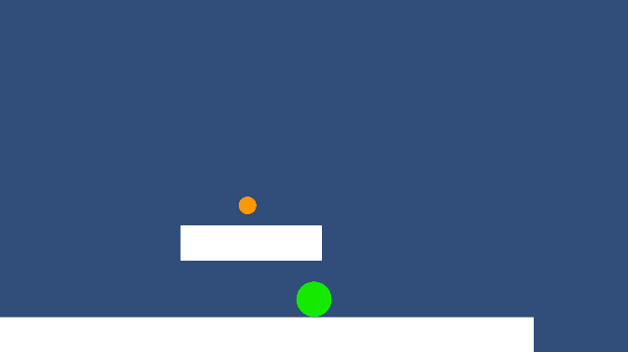

Camera: “leap of faith” camera angle is really low making it so that the player can not see what is beneath them. This created a feeling of anxiety when playing the game because the player could not see if they where going to land on a platform or a gap. The camera follows the player as the player moves with a slight delay. This element added to the feeling of anxiety because when falling from a high platform the player would disappear from the screen and if they fell into a gap, they would start the whole level from scratch.

The low camera angle is nice for that feeling of anxiety but combined with the camera delay it got frustrating sometimes when you could not see where the gap was that killed you. The game proved to hard.

Thus, the group decided to move the angle up a bit to give the player more vision of the platforms beneath them. This made the game much easier so the group decided to add moving platforms at the end of the level to give the feeling of a “boss” that needs to be completed before taking the final leap of faith.

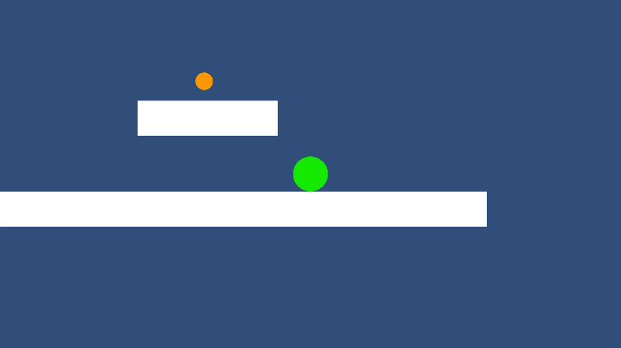

Other changes:

* End platform (have collected everything): stop movement. Tell the player they have won and give option to restart or go back to main menu. Stop player movement (if they have won.
* End platform (not collected all the collectables): when landing on the platform. Display a message telling the player to kill themselves and restart the level.
* Moving platforms. To enhance the difficulty of the game because the camera angle was moved up a bit.
* Timer. A timer is added that start from 0 and continues until the player is done with the level. In the main menu the latest time will be displayed.
* UI: take the curser away in game, bring it back when the pause menu or win menu pops up. Option to resume the game or exit the game in pause menu.